Blood Suckers II™
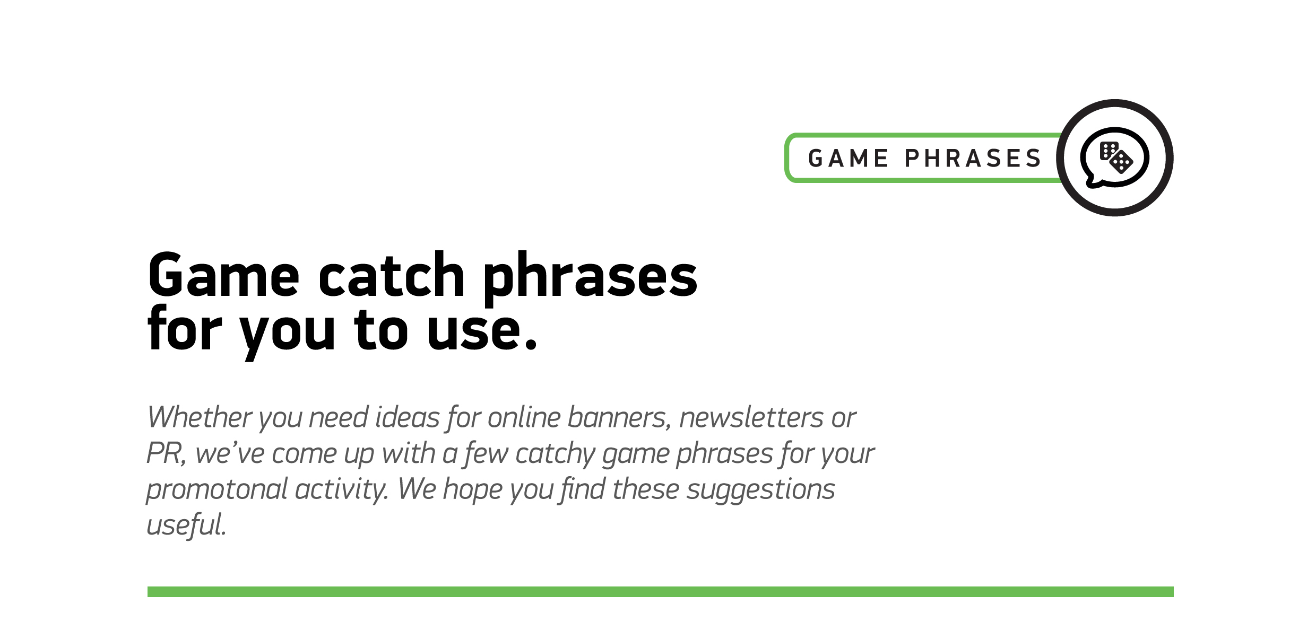

1
It’s time to raise the stakes
2
It’s time to raise the stakes: the vampires have returned
3
Brave unspeakable evil - win untold riches
4
Join a vampire’s quest to discover the wealth of her ancestors
5

Pierce the heart of darkness and discover untold riches

6

Slots, stakes and crossbows – Join Amilia the vampiress on her latest adventure

7

A dark evil guards the vampire’s treasure

