Universal Monsters Dracula Online Slot™
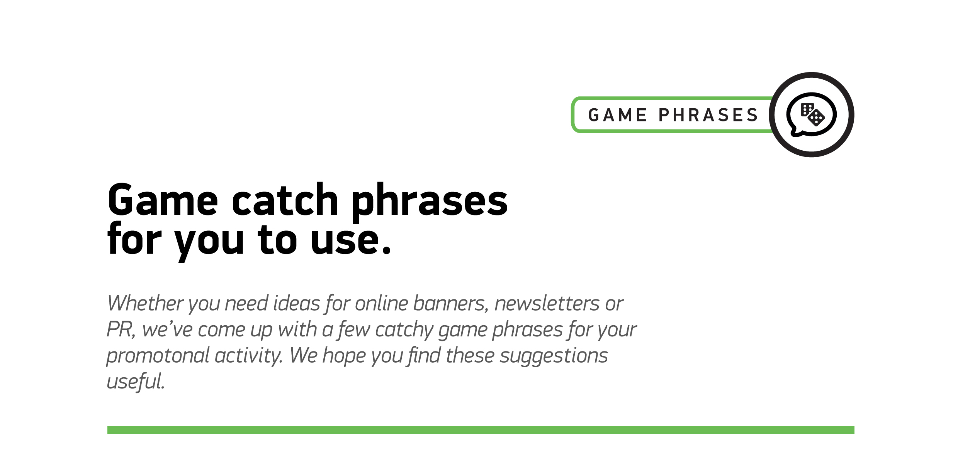

1
We’ve raised the stakes to bring you our fang-tastic new slot, Dracula!
2
Sink your teeth into this reel Transylvanian treat!
3
Take fright. Play Dracula!
4
Reel in the frightful thrills…
5
Stake your claim in this spine-chilling slot!
6
Play Dracula; it’s frighteningly fabulous!
7
Take a spin through Transylvania
8
Enjoy slots of spooky spins!
9
We’ve raised the stakes in slot games!

