BOOnanza game phrases
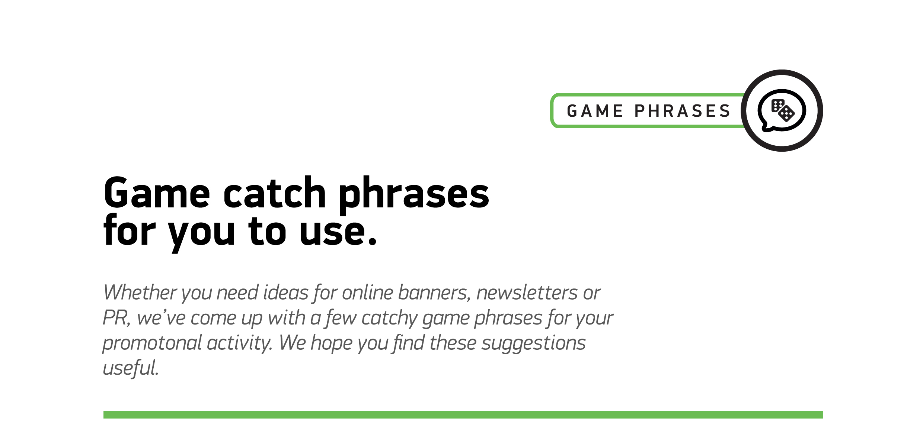

1
Stake your claim in this spine-chilling slot!
2
It’s time to raise the stakes
3
Brave unspeakable evil - win untold riches
4
Want fang-tastic fun? Play Blood Suckers™
5
Enjoy slots of spooky spins!
6
Enjoy this frightfully fantastic vampire BOOnanza
7
Take a bite out of these blood-chilling slots
8
Play our fiendishly fun vampire favorites

