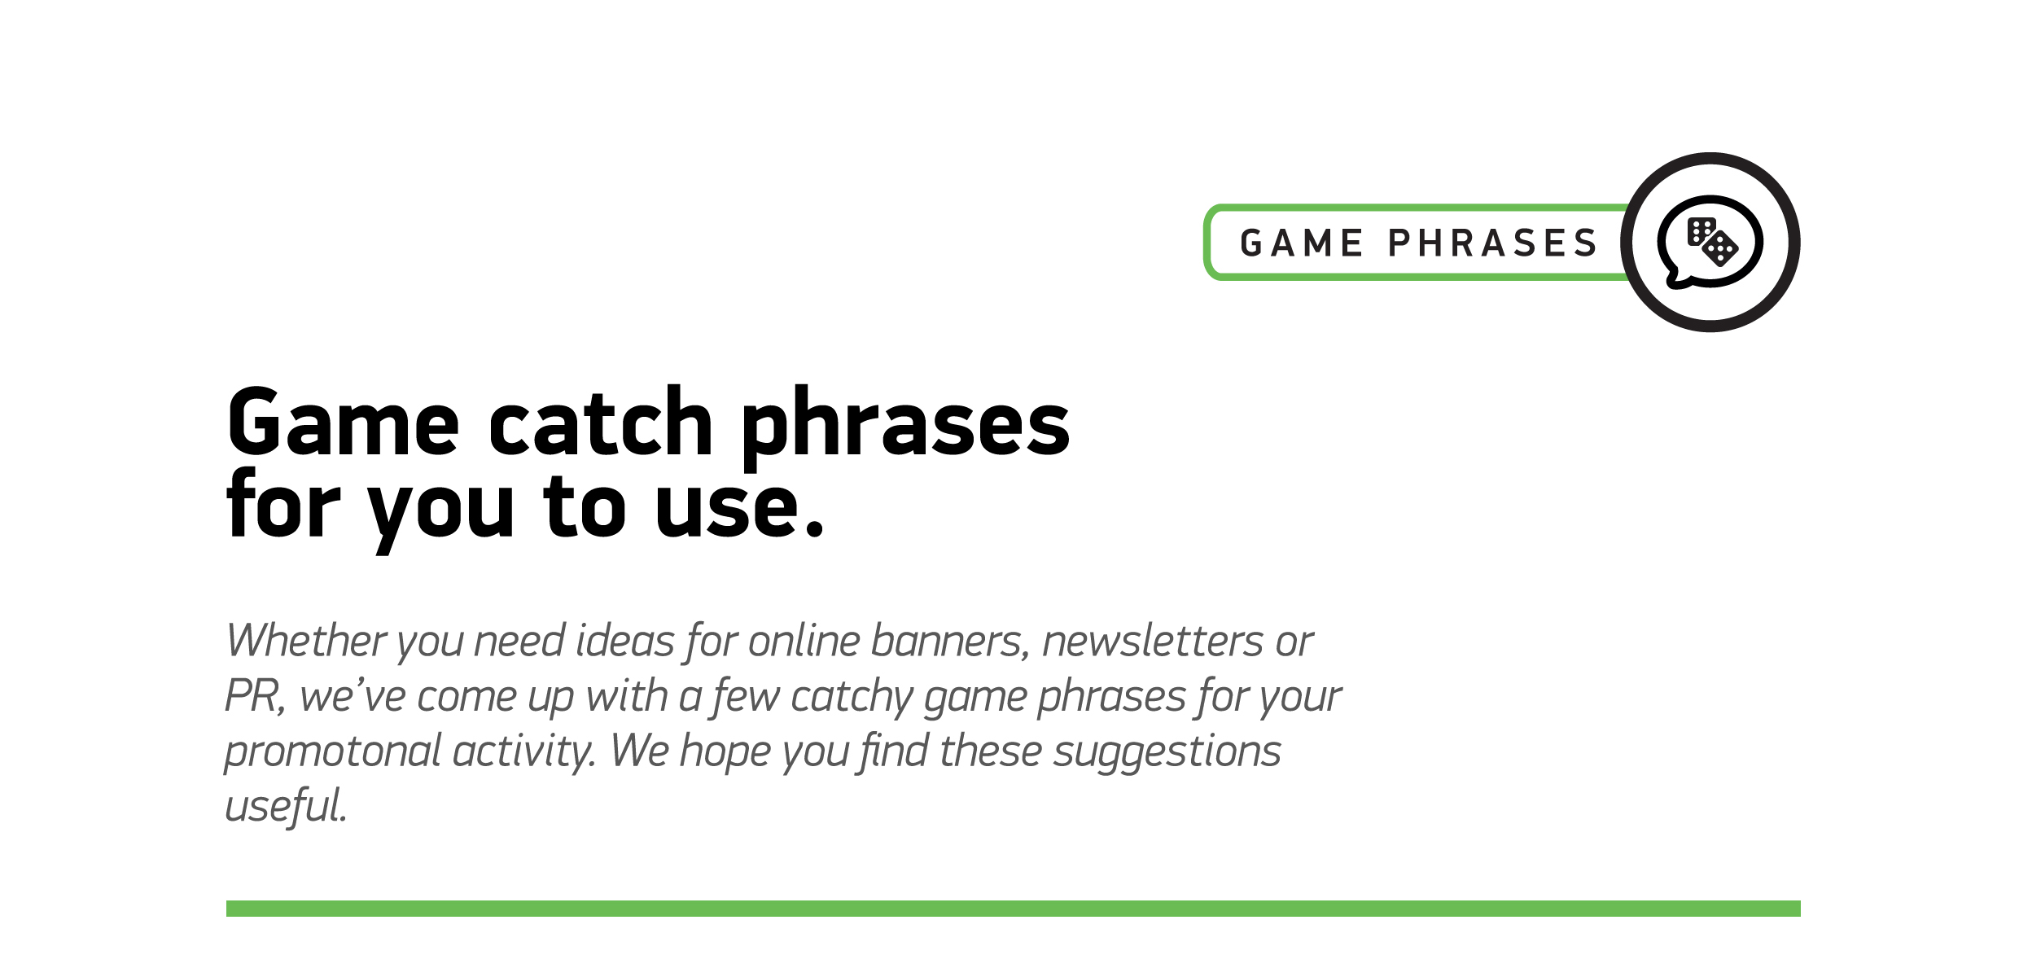
Go Bananas™

1
‘Monkeying around has never been such fun– it’s time to Go Bananas™’
2
‘Go Bananas™, it’s very ap’peel’ing!’
3
‘The jungle’s in full swing with mischievous monkey madness. Are you ready to Go Bananas™?’
4
‘It’s wild whimsical fun at its finest. It’s Go Bananas™’
5
‘Want to swing with the craziest apes around? Go wild. Go Bananas™’
6
‘Join a mischievous bunch of monkeys as they Go Bananas™ in the jungle’
7
‘You’ll swing when you win in our action-packed slot, Go Bananas™’
8
‘For fast-paced monkey mayhem, Go Bananas™’
9
‘Go Bananas™ brings an action-packed frenzy of mischievous monkey mayhem!’

