Goal Smash Promotion
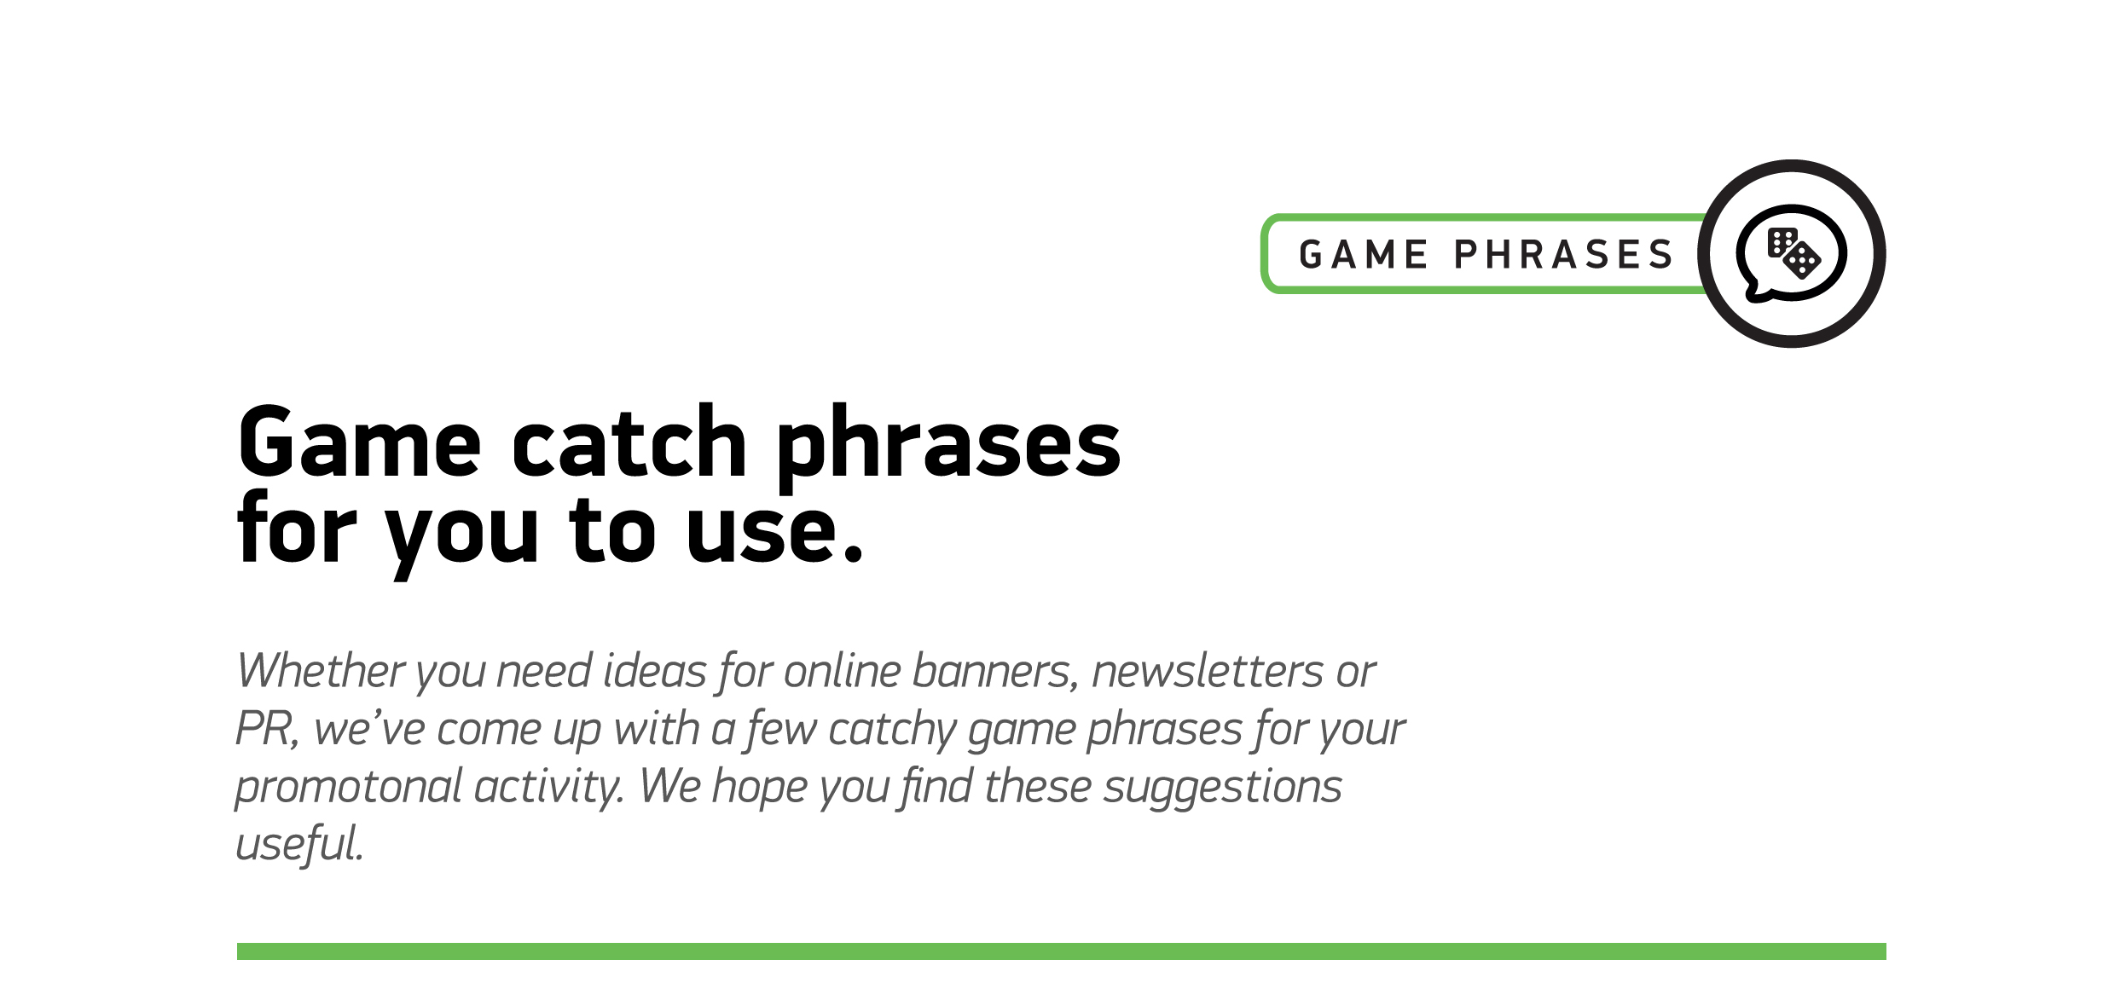

1
Football fever is about to hit maximum
2
Crank up the heat with our summer football promotion
3
The beautiful game deserves the best Roulette experience
4
This summer, there is one cup, one team, and only one promotion
5
A wave of football mania is gripping the world – get in on the action!
6
Get your boots on and get ready for a game-winning promo
7
The perfect fusion of Roulette and Live Football
8
Experience Football through Roulette with Goal Smash

