Stickers™
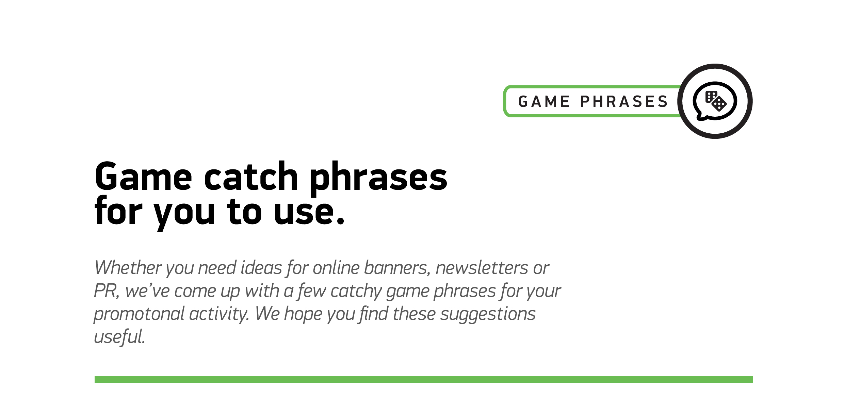

1
Get stuck in!
2
You’ll be glued to the excitement of Stickers!
3
Sticky spins give big wins!
4
Reel in the sticky charm…
5
Reel excitement that’s sure to stick!
6
Go wild for the sticky spins!

