Sparks™
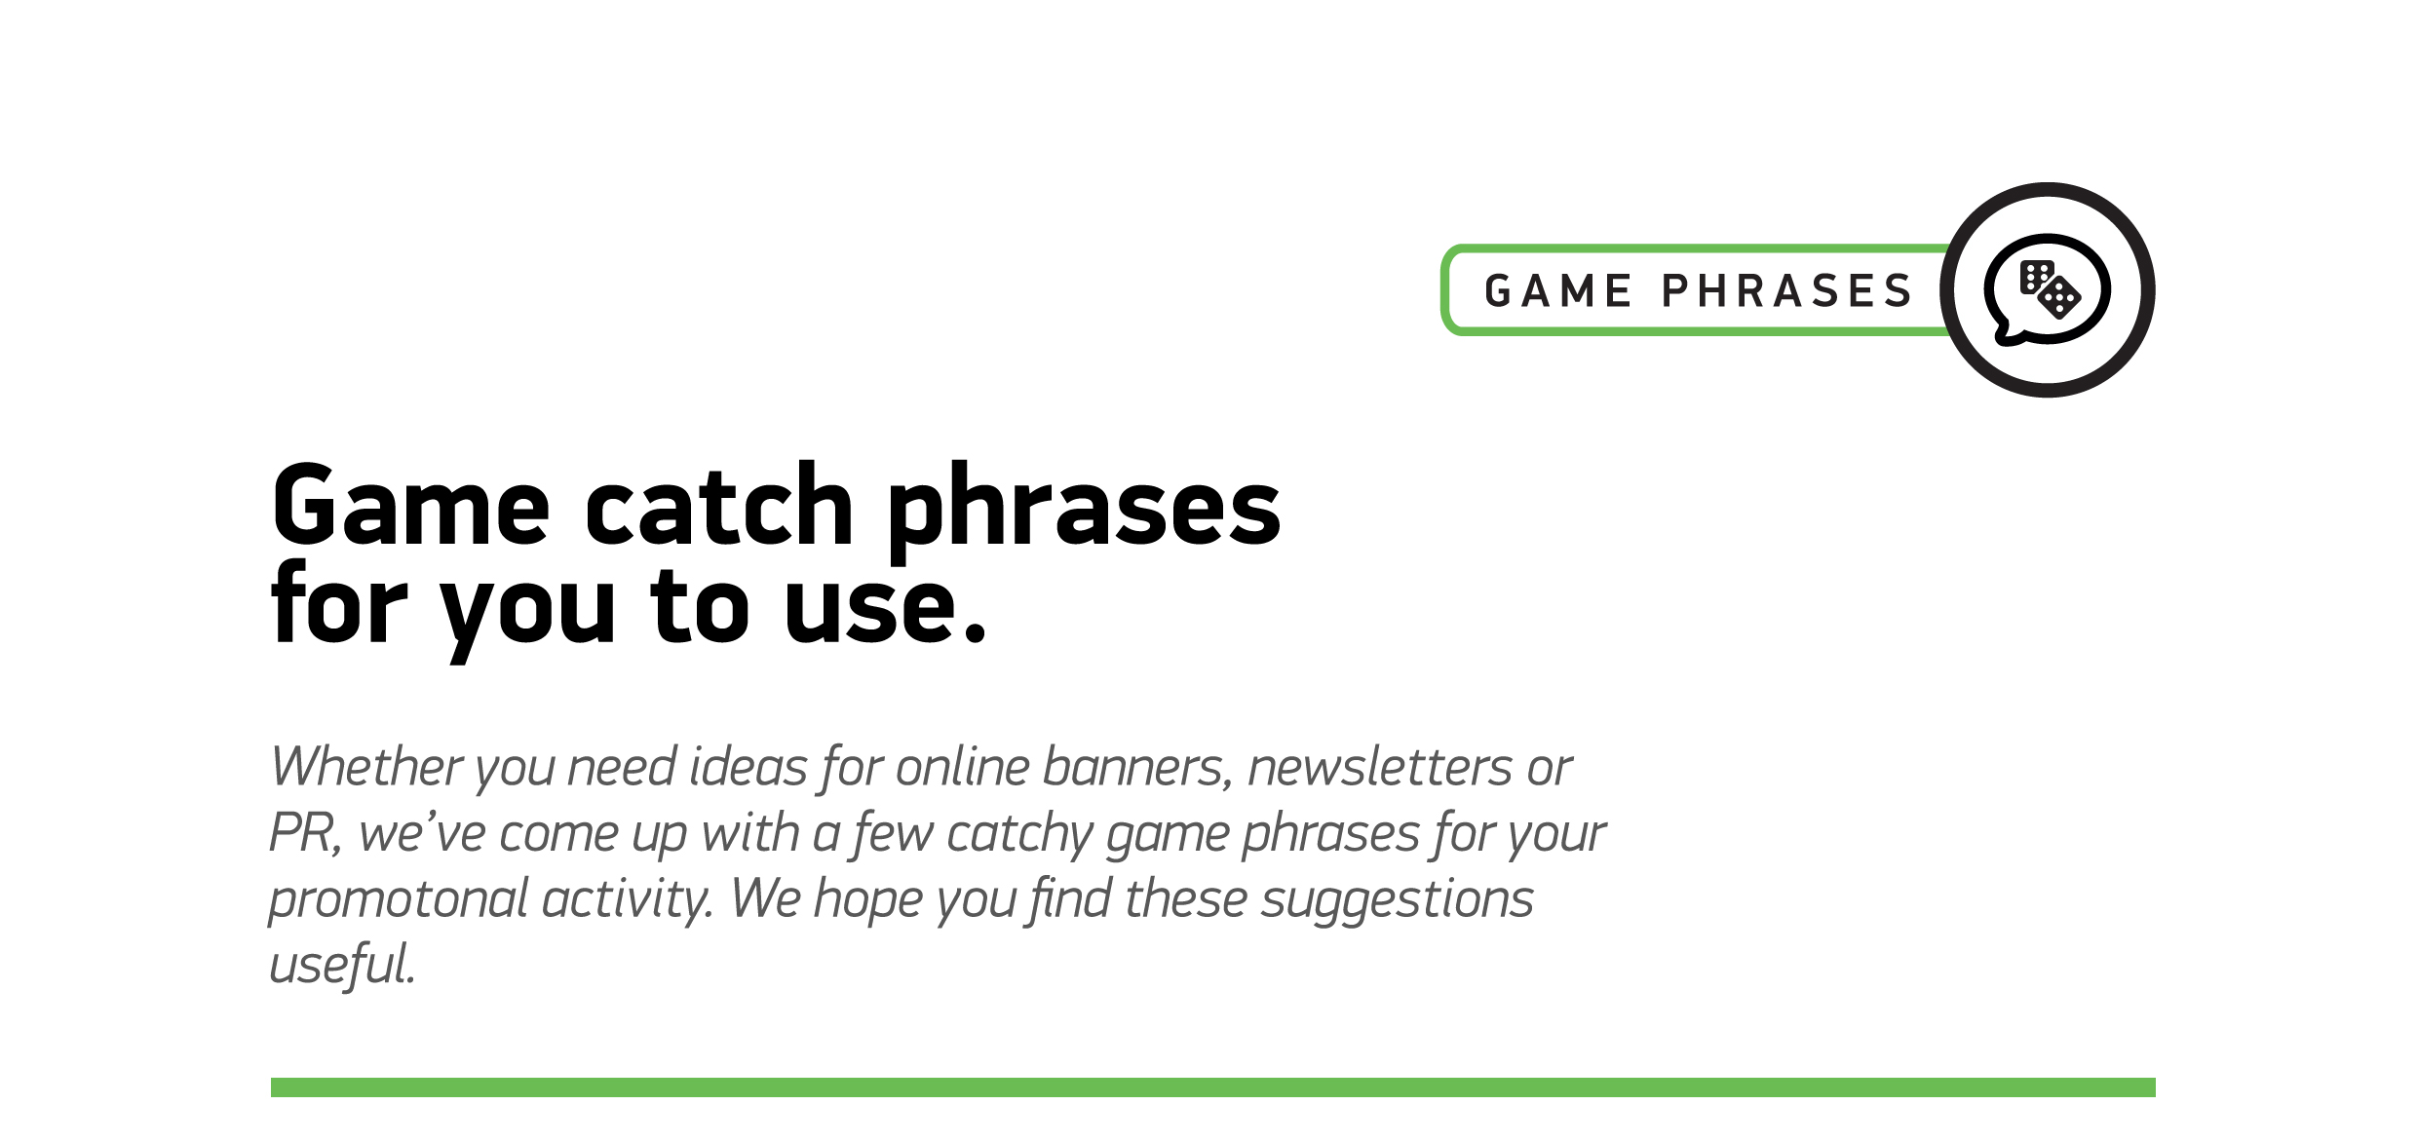

1
Sparks™ gives you two ways to play!
2
Take a spin on Sparks™
3
For a sizzling spin and two ways to win!
4
Sparks™ are going to fly
5
Play Sparks™. It’s electrifying!
6
Fancy making sparks™ fly? Play now…
7
Choose your way to play…
8
You in for an electrifying spin?

