Hook’s Heroes™
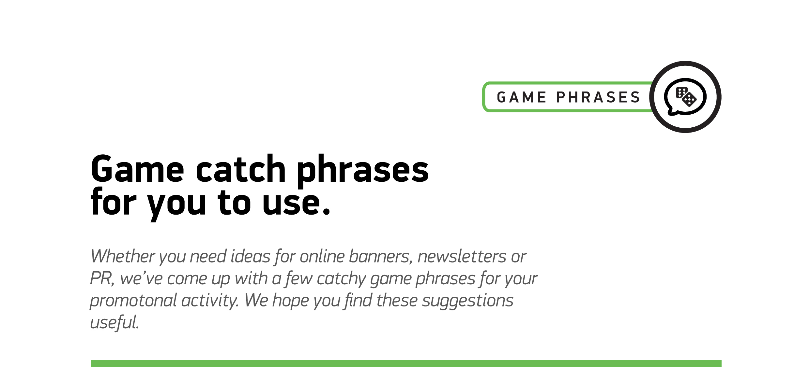

1
Anchors aweigh… play Hook’s Heroes today!
2
The adventure’s on. Are you ready?
3
Check out our new slot… you’re sure to get hooked!
4
Reel in the treasure-tastic treats of Hook’s Heroes…
5
There’s no hook, line, and sinker here. Play Hook’s Heroes now!
6
Get hooked into our new game…
7
Ahoy there. Hook’s Heroes is here…
8
Go on push the boat out. Play Hook’s Heroes…

