Koi Princess™
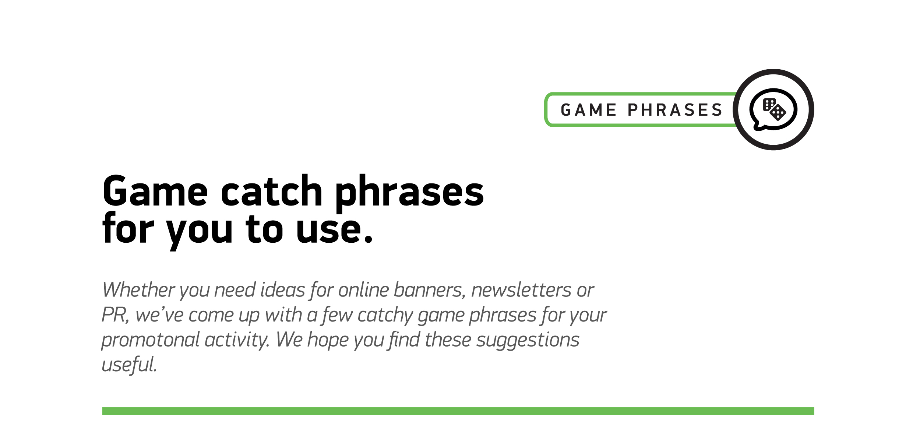

1
Koi Princess™ is loaded with luck!
2
Reel in the fortunes of Koi Princess™…
3
Fish out the fantastic bonus features…
4
For feature-rich fun that’s off the scale!
5
Spin with the fishes and find your fortune…
6
Koi Princess™ is seriously big on bonus features
7
You bet you’ll have fun with Koi Princess™!
8
There’s never been so many ways to win!
9
Spin the Bonus Wheel to trigger bigger Free Spins

