Wolf Cub™
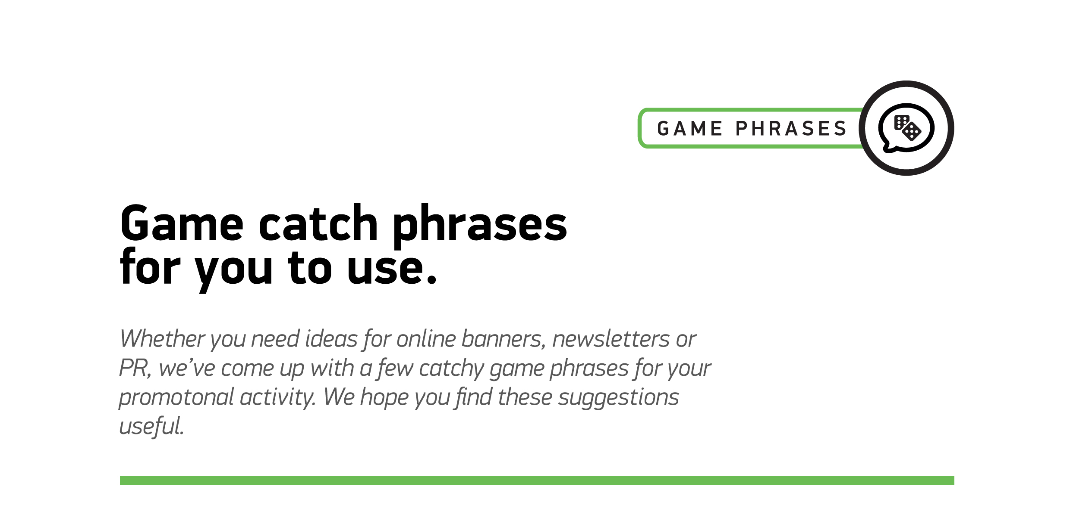

1
Join Wolfie and pack your pockets with big wins
2
Join the pack!
3
Get ready for a howling adventure!
4
A blizzard of fur-tastic fun!
5

Crank up the cuteness with this adorable new game

6

You are a whisker away from massive wins

7

Let’s get fuzzy!

