Lost Relics™
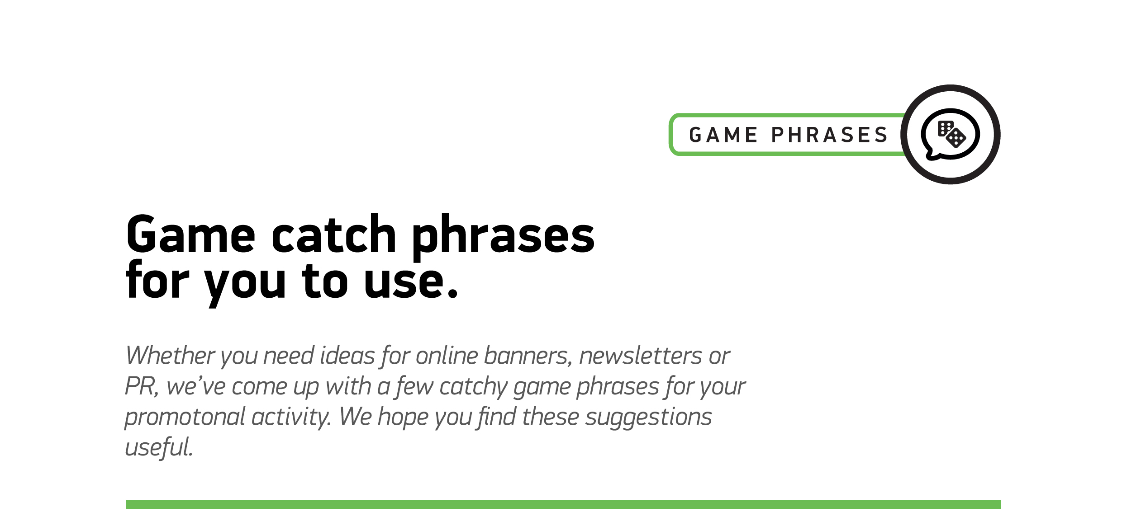

1
Lost in time but not for long: introducing Lost Relics™

2
Gold Relics, Ancient Jewelry and… free spins? There’s a lot to discover in NetEnt’s latest offering Lost Relics™

3
There’s no turning back until you find what you seek

4
History meets slots in NetEnt’s latest game of the ages: Lost Relics™

5
Time to head out for an archaeological adventure!

6
Who knew the ancients loved free spins as much as we do!

7
Your destiny lies in the sands of time

